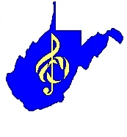
WV State Show Choir Festival

INSTRUMENTAL ENSEMBLE
^{(Please fill in the grey area)}

SCHOOL DIRECTOR

I will be using taped accompaniment Yes No
The director will be playing in the instrumental ensemble: Yes No
An adult (up to 2) will be playing in the instrumental ensemble: Yes No

Please list the instrument the following will be playing:
Director: Adult 1: Adult 2:

(If an instrument group uses any adult besides the director, they are not qualified for the instrumental ensemble caption award)

(10 points possible per category)
 | POINTS | COMMENTS
INTONATION--within the section, to the keyboard, etc.
INTERPRETATION--Style, tempo, dynamics, phrasing, musicality.
BALANCE--within the ensemble, with the singers
PRECISION--Rhythmic accuracy, attacks, releases.
TOTAL POINTS

Judge Signature:__________________________________________________________

