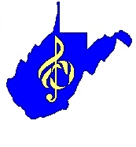
WV State Show Choir Festival

COPYRIGHT RELEASE AGREEMENT
(fill in the grey boxes)

It is agreed that (school name) School is responsible for securing the payment of performance rights and copyright license fee(s) for any music performance in conjunction with their use at the WV State Show Choir Festival.

(High school name) School agrees to defend, indemnify and to hold harmless WV Vocal Musical Association against all claims, demands, costs, expenses and attorney fees that may sustain or incur by reason of any infringement or violation of any copyright or proprietary right in connection with the permission granted herein.

Agreed

Director’s Signature:

School/Choir Name:

ALL PARTICIPANTS MUST SUBMIT, ALONG WITH THIS FORM, COPIES OF THEIR MUSIC LICENSING IF THEY ARE NOT USING STOCK ARRANGEMENTS. GROUPS WHO DO NOT SUBMIT THEIR LICENSES, WILL NOT BE ALLOWED TO PARTICIPATE.

CHECK THIS BOX IF YOU ARE USING STOCK ARRANGEMENTS:

